CUSTOMER SEGEMENTATION

Physical data flow diagram:

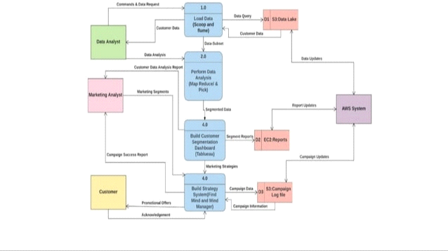

Logical data flow diagram:

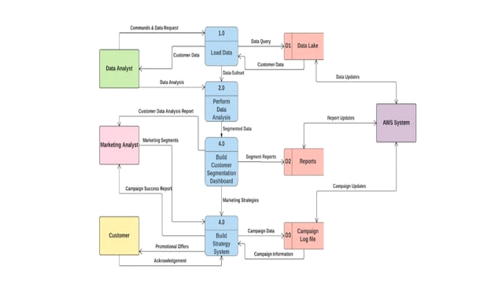

Data flow diagram:

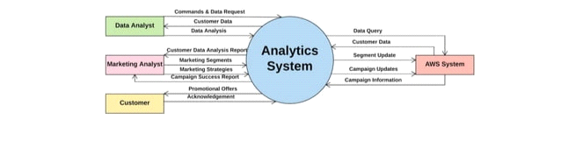

Logical entity relational diagram:

